

***Operating systems Lab Work***

***Practical 7***

***Name :Shrey Vyas***

***Batch:F-1***

***Roll Number:22BCE335***

7A.

Code:

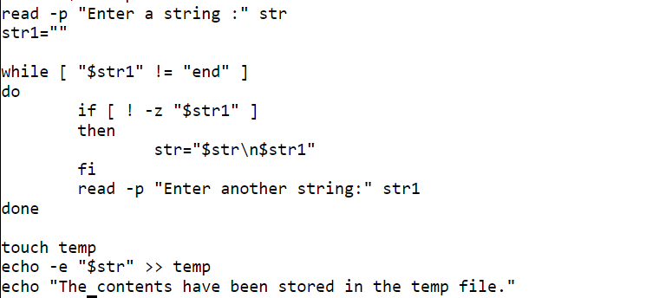

Output:

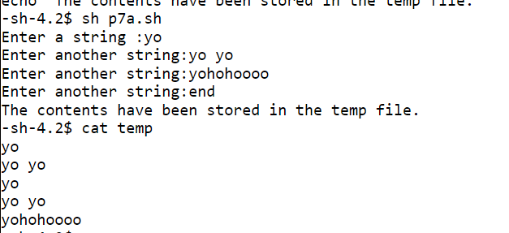

7B.

Code:

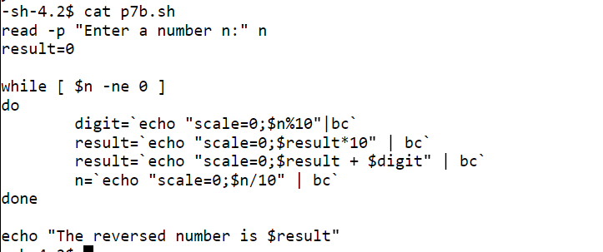

Output:

